NCC Activities and Achievements from the Academic year 2023 to 14th Feb 2024

CPR and AED Training
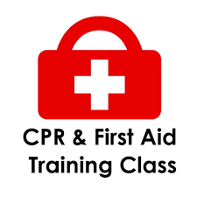
In a proactive response to the unfortunate passing of our fellow college mate, Abhiram from the S1 Mechanical department, the NCC unit of FISAT organized a highly informative awareness session on 13 October 2023. The event aimed to equip First year B.Tech students with the skills necessary for Cardiopulmonary Resuscitation (CPR) and the operation of an Automated External Defibrillator (AED). The session was skilfully conducted by Anish Isaac, an American Heart Association instructor, renowned for his expertise in life-saving techniques. The program was a collaborative effort between junior and senior cadets of the NCC, united in their mission to provide practical knowledge to their peers. Their goal was to empower students with the ability to administer CPR effectively and operate an AED, thus enabling them to be of assistance during medical emergencies and potentially save lives.
https://www.instagram.com/p/CypnYvEsDHd/

Successfully Completed IGC Republic Day Camp
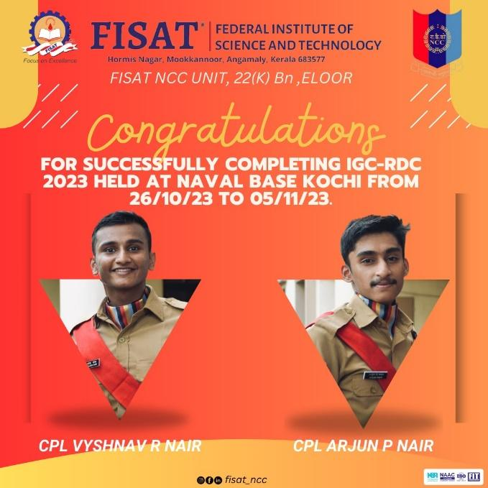

NCC DAY Celebrations
FISAT Chairman Shimit P R started NCC Day celebration by NCC flag hoisting ceremony for the NCC DAY Celebration of 26th November 2023. The National Cadet Corps (NCC) is the largest voluntary youth organization of the world that provides military training to students. The NCC aims to develop character, discipline, leadership, and a sense of citizenship among the youth.

Invited Talk by Col.H Padmanabhan
Col.H Padmanabhan retired NCC commanding officer of 22 K Bn, with a wealth of experience in training and motivating young people interacted with FISAT students on 27th November 2023 in the seminar with first year and second year B.Tech students of FISAT. He shared his insights on the importance of youths and NCC in shaping the future of India.

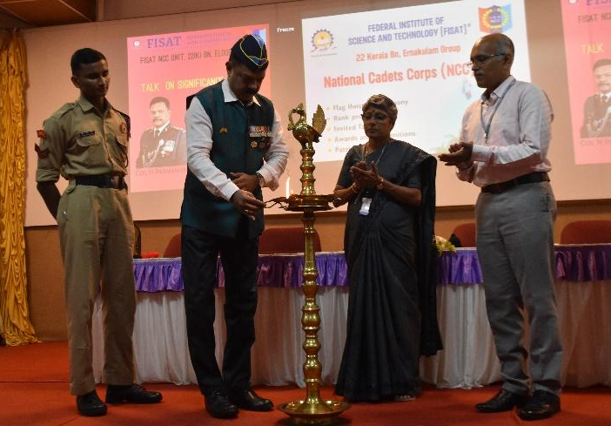

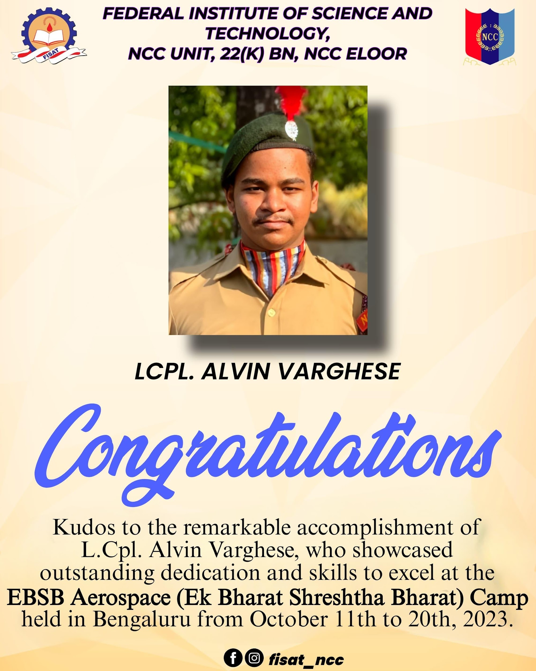

Rank Promotion
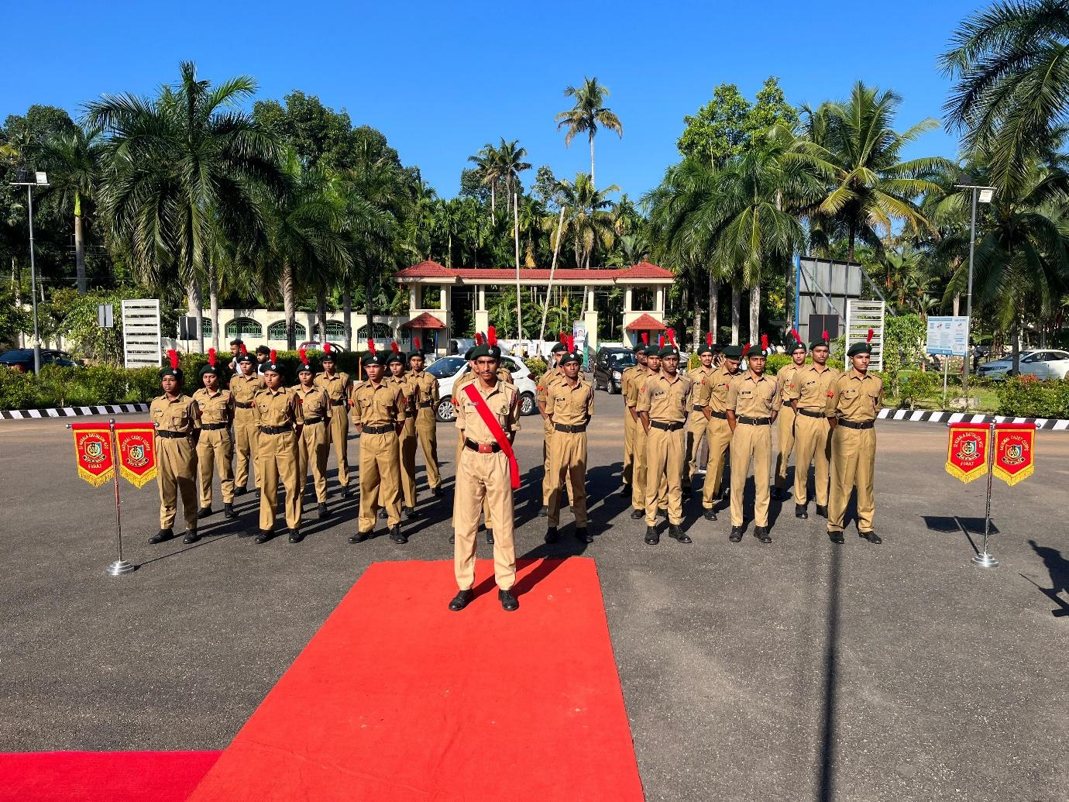
Based on the performance in various activities, parade and test and interview, the Lace Corporals Lcpl.Arjun P Nair, Lcpl.Vyshnav Rajesh Nair and Lcpl.Shreyalakshmi Shankar
were promoted to Corporal Rank and cadets Cdt. Ann Mary Benny, Cdt. Athulraj Appukuttan and Cdt. Ashikh P K were promoted to Lance Corporal Rank. Chairman Shimit P R awarded the ranks to promoted members.

NCC Cadets Assisted Angamaly Police
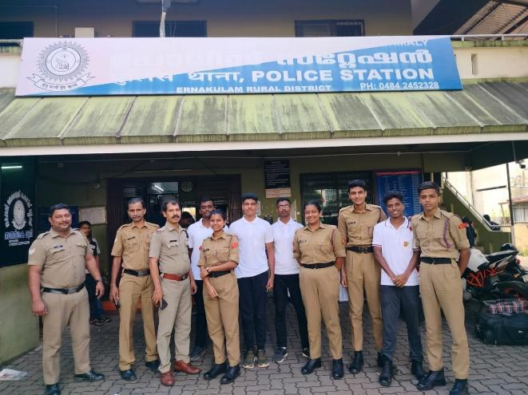
On Sunday, the 15th of October 2023, a group of National Cadet Corps (NCC) cadets, responded to a request from the Circle Inspector to assist at the Angamaly police station. The purpose of this mission was to input data regarding out of-state workers into the police database. It served as a reminder of our duty to assist our community and collaborate with law enforcement agencies to
ensure the safety and well-being of society.

'Swachhata Hi Seva' Campaign
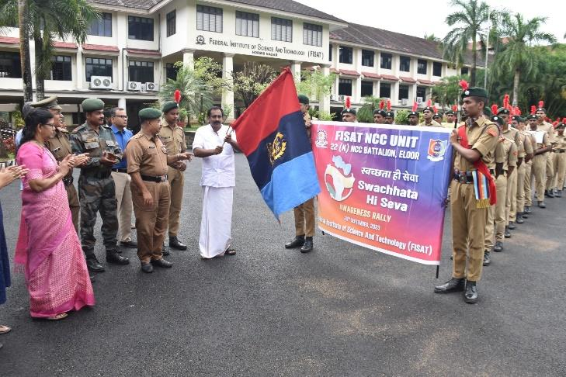
On the occasion of Gandhi Jayanthi Week Celebration program ‘to clean the village’ ,FISAT NCC unit organized a 'Swachhata Hi Seva' Campaign Awareness Rally. The rally was flagged off by Mookkannoor Panchayath president Sri.Biju Palatty. The rally started from the FISAT campus and passed through the nearby places, spreading awareness about the importance of cleanliness and hygiene. The participants of the rally chanted slogans and carried placards with messages such as "Cleanliness is next to godliness," "Swachh Bharat Abhiyan," etc.

The Floral Tribute to Mahatma Gandhiji
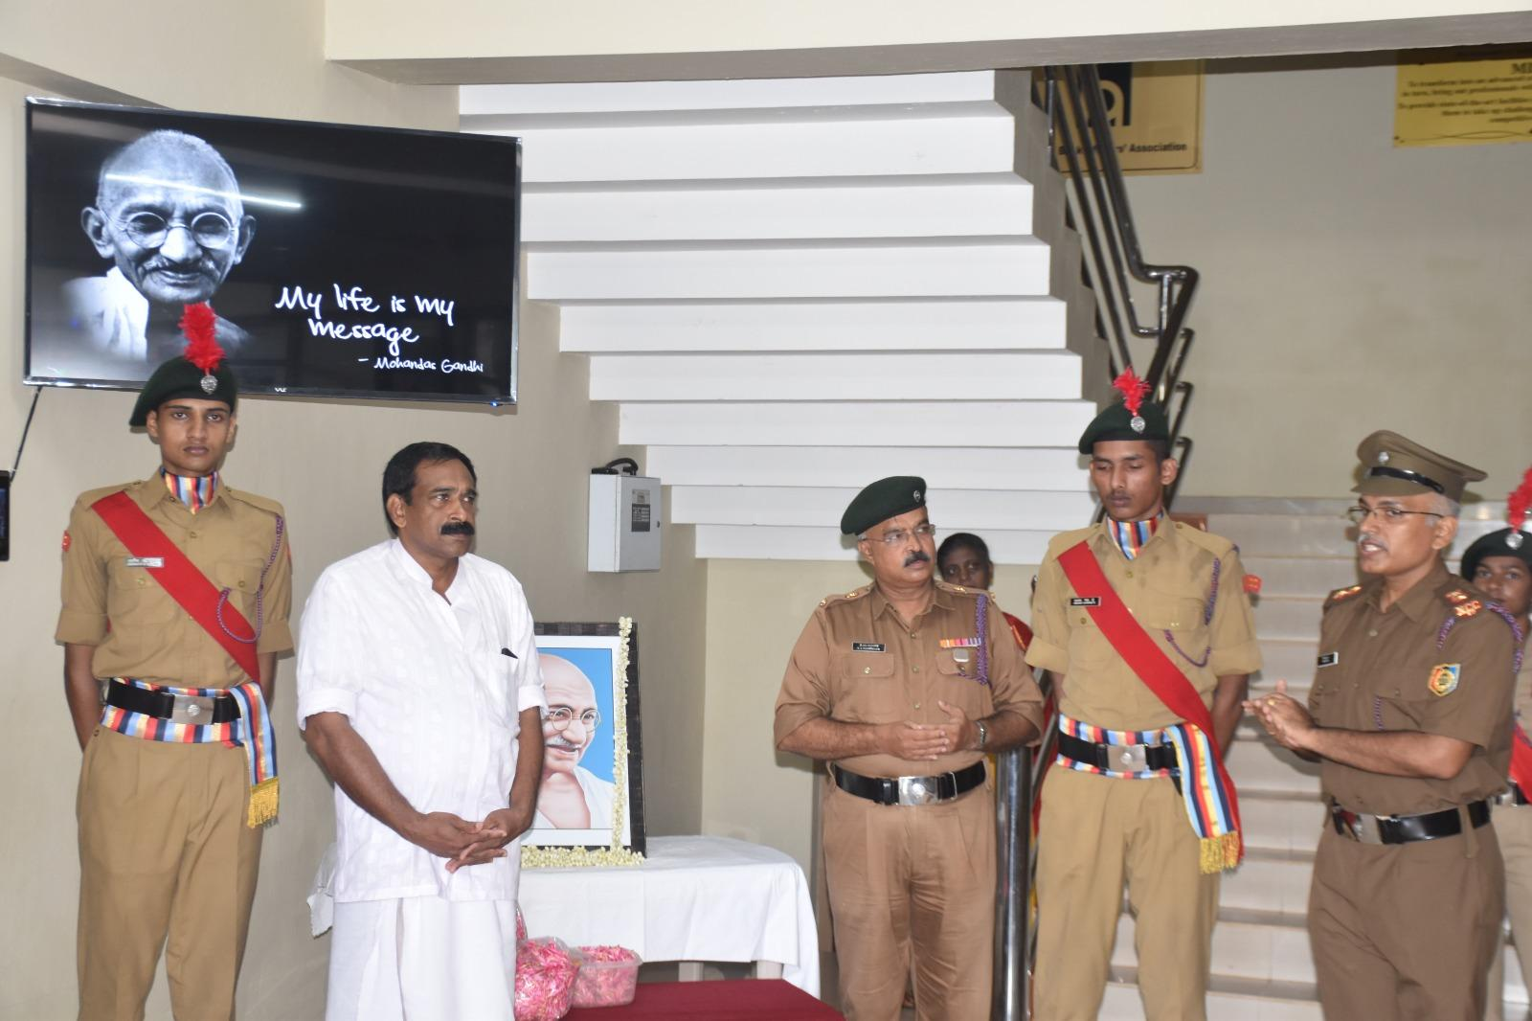
The Floral Tribute to Gandji was a cultural event held on the occasion of Mahatma Gandhi's 153rd birth anniversary at the FISAT campus in the presence of students and faculty members. The event featured songs on the life and teachings of Mahatma Gandhi. Mookkannor Panchayath President Sri. Biju Palatty, spoke about the importance of following Gandhi's ideals of cleanliness, non-violence, and truth.

Anti Narcotic Seminar
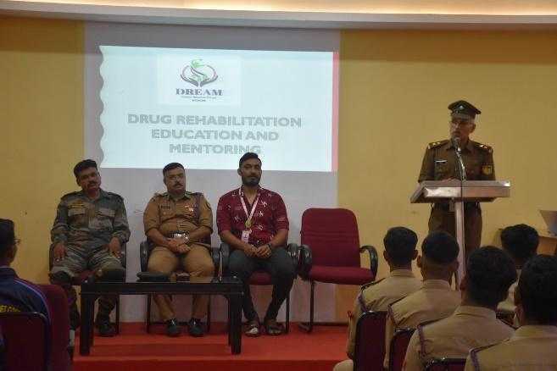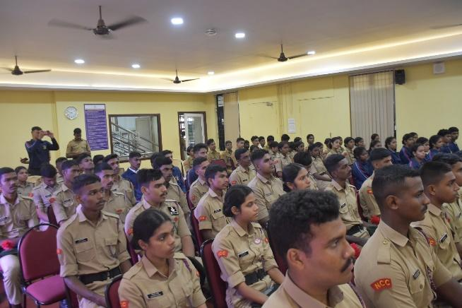
A seminar on Anti Narcotic was conducted, led by DREAM district cordnator Shibin Shaji Varghese on 1st October 2023. Principal Dr.Mini P R, Major Narayanan, Lt.Dr.Prasad J C, Sub.Major Manoj ,Dr.C Sheela, Director R&D, Dr.Unnikartha, Dean, and Lcpl Vyshnave spoke on the occation.

Metro Water and Metro Train Journey with Kripa Sadan Old Age Home members.
As part of Social Service programme of NCC FISAT, Cadets conducted a Metro Water and Metro Train Journey with Kripa Sadan Old Age Home members on 25th Septemebr 2023. Team Visited Vytila Metro Station and Kakkanad Water metro Station and took dinner from one of the Best Restaurant of Angamaly. It was a great and unforgettable experience for each members of the team.
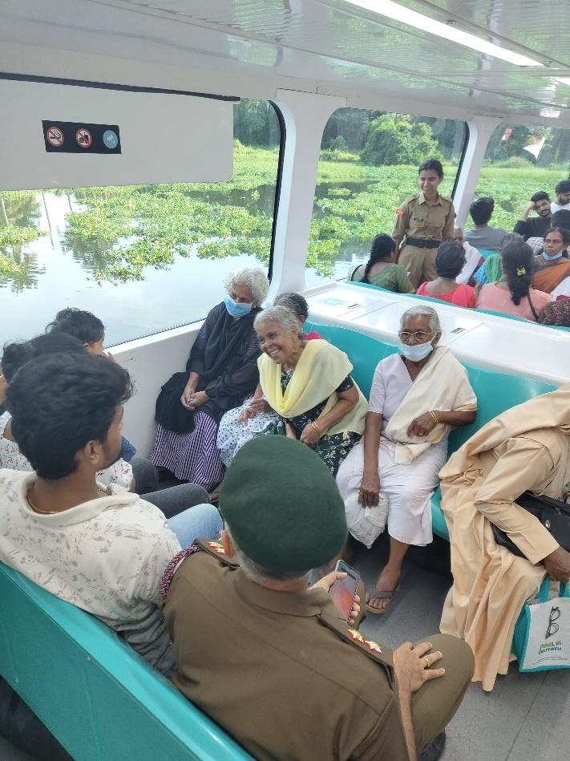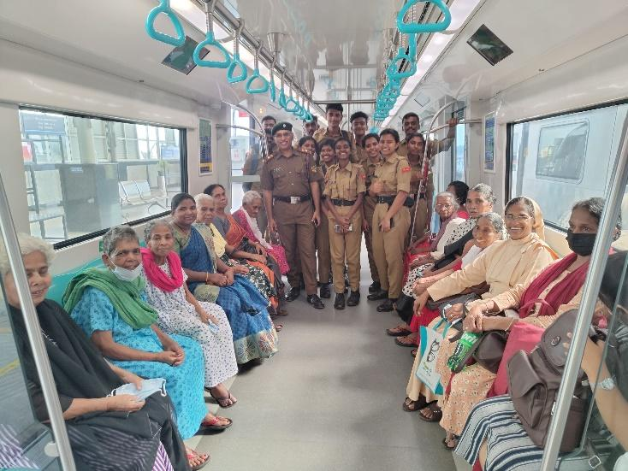

Cleaning Mookkannoor Town and Roads.
NCC Cadets cleaned 5 Km road in association with Mookkannoor Grama panchayath as part of Gandhi Jayanthi Cleaning Week Awareness Programme. Many Public, school children, members of haritha karma Sena, etc participated in the cleaning programme. Panchayath President Biju Palatty and Vice President Jaya Radhakrishnan Congratulated and interacted FISAT NCC cadets and distributed refreshments on the same day.

District Level Quiz Competition Winners
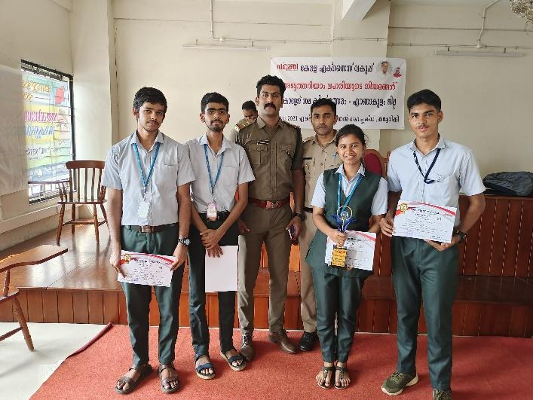
NCC Cadets & NSS Volunteers of FISAT won 2nd and 4th prizes in District Level Quiz Competition organized by The Kerala Excise Department on 30-11-2023 at Ernakulam Zonal Office Complex, Kacheripady. Cdt. Vigneswar S Kumar(S1 ECE B) and NSS Volunteer Sooraj C R( S3 CSE C) won second position. Lcpl. Annmary Benny(S3 EIE) and NSS Volunteer Neeraj Suresh(S3 CSE C) got fourth position.

Orange the World Campaign Day
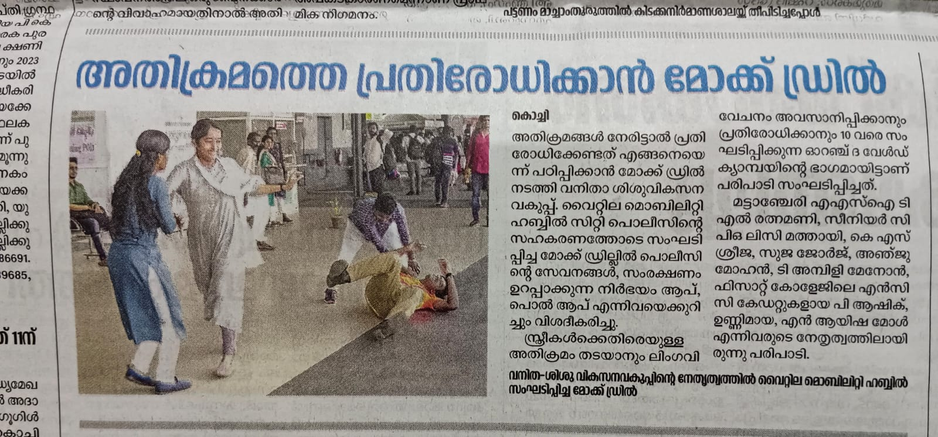
On November 25, 2023, the Vyttila Hub became a focal point for the Orange the World Campaign, emphasizing the crucial involvement of men in combating violence against women. The event commenced at 11 am, with the active participation of the District level Women and Children's Welfare Committee, representatives from the Kerala Police and along with Fisat ncc cadets.

The event featured a self defense technique for women . The Women and Children's Welfare Committee played a pivotal role in orchestrating the day's activities, fostering a supportive environment for dialogue. The presence of the Kerala Police underscored the commitment to ensuring the safety and well-being of women in the community. The Orange the World Campaign Day at Vyttila Hub served as a beacon of hope, inspiring positive change and reinforcing the importance of collaborative efforts in creating a safer and more inclusive society for all.
Essay Writing Competition
‘Role of Millets for Sustainable Future’ essay writing competition was conducted among college students on 15th Dec 2023.
Christmas Celebration
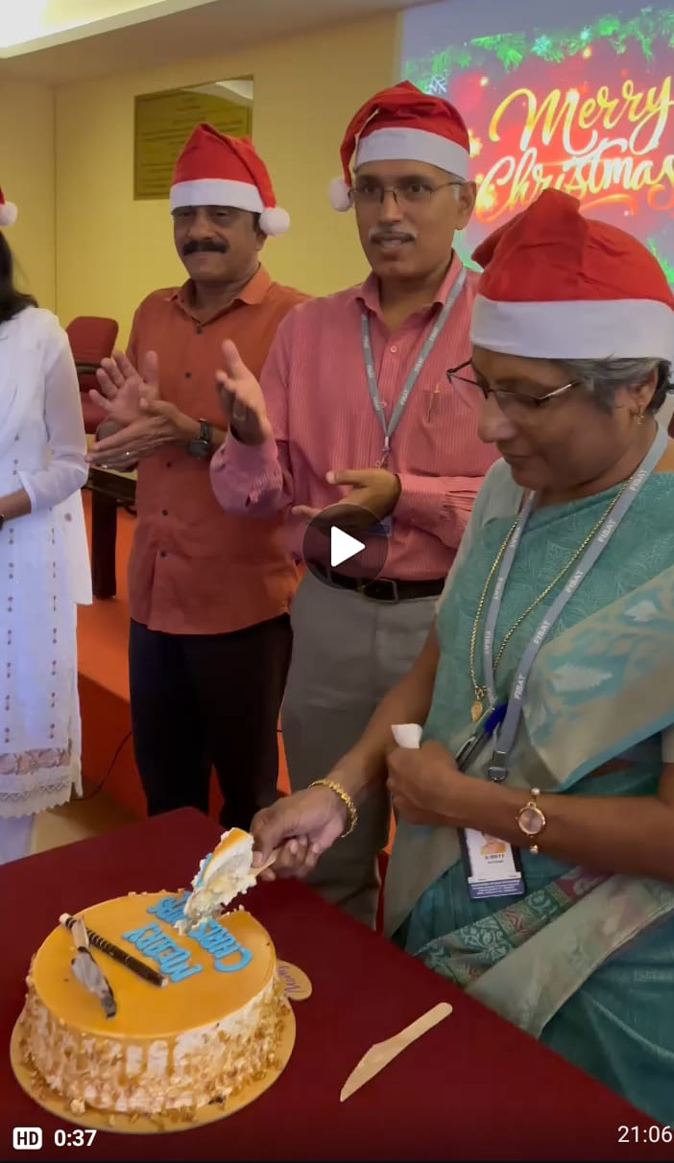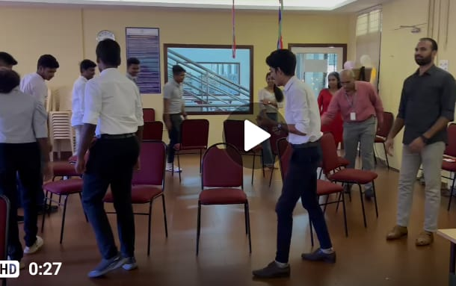
Cultural Programmes, Games, and christmas meeting with games activities conducted on 22nd Dec 2023.
Camp Attended
Five NCC Cadets successfully attended CATC Camp from 21 Dec 2023 to 31 Dec 2023 at St Pauls College Kalamassery
National Level Camp
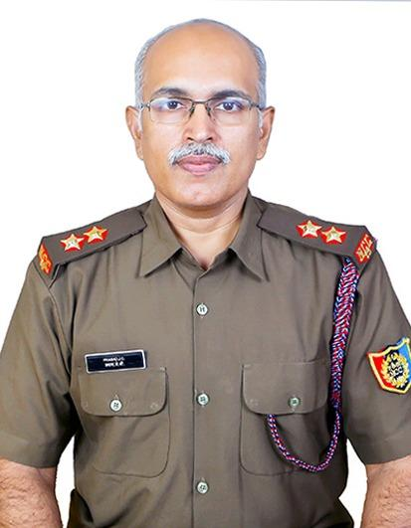
Lt.Dr.Prasad J C lead Kerala NCC Team as 2IC Contingent Commander of 150 Cadets to Ahamadabad, Gujarat for the National Level Camp ‘Ek Bharath Sreshta Bharath’ Camp from 6th January to 22 January 2024.

Best Shooter Award from Bn
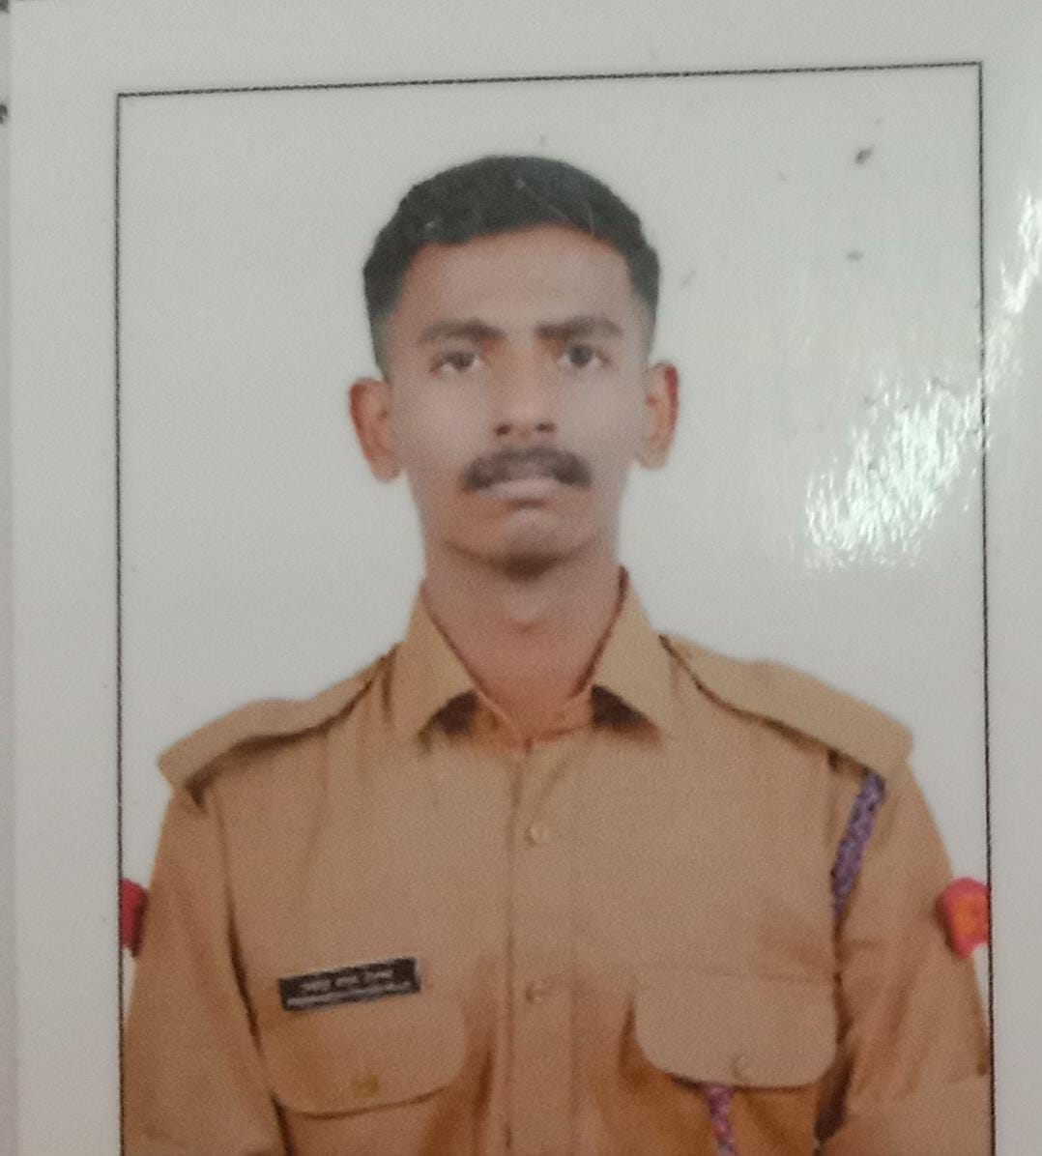
Cdt.Pradhamesh Prasad Pillai received the Best Firer Award representing NCC FISAT UNIT in 22 Kerala Bn on 27th December 2023.

Tribute to Pulwama Martyrs
Date : 14th February 2024, Time : 8:45 - 9:00 am

On the significant day of 14 February 2024, celebrated as Valentine's Day but the NCC Unit of FISAT college decided to give tribute to the 40 soldiers who sacrificed their life in the Pulwama attak which was held 5 years ago on this day.
The ceremony started with the NCC guard team commanding. As a tribute to the soldiers the principal Dr.jacob Thomas devoted the garland on the statue of Amar Javan and also floral tribute was given. The ceremony was ended by honoring them with salute and by National Anthem.
