R&D Cell -Report
Objectives of R&D Cell
R&D Cell is committed to promote quality research among faculty members and research scholars. The Cell envisions to provide adequate infrastructure facilities and other support for collaborative research and product development. The following are the major activities envisaged by the Cell:
- Promoting Research and Innovation culture among the faculty members and students.
- Coordinating Research work of faculty members and research scholars
- Promoting interdisciplinary research
- Helping the faculty members / Departments in preparing Minor/Major Project proposals to various funding agencies.
- Establishing a ‘Project Bank’ and monitoring the project proposals.
- Coordinating periodical review meetings on the progress of research being carried out by Ph.D. scholars.
- Coordinating systematic review of the progress of funded projects.
- Guiding researchers in filing patents.
- Organizing seminars/workshops for Ph.D scholars/PG students.
- Exploring the proposals for establishing a new research centre.
- Provide the report of the activities of the Cell or Institute.
- Any other duties assigned by the Principal / Management.
List of Newly Approved Research Supervisors of KTU in AY 2023-24
Five new research supervisors were approved by KTU from various departments in the academic year 2023-2024.
- Dr. Jyothish K John, Computer Science & Engineering department
- Dr. Hema Krishnan, Computer Science & Engineering department
- Dr. Reshmi R, Computer Science & Engineering department
- Dr.Shahna K U, Computer Application department
- Dr.Surya Susan Alex, Department of EEE

List of Approved Research Supervisors of KTU/Supervisor activation date
There are 19 approved research supervisors from various departments. A detailed list is given below.
- Dr.Jacob Thomas V , Principal (15/09/2017)
- Dr. Arun kumar M N, Professor, Department of CSE (19/10/2018)
- Dr. Anil Kumar M N, Professor, Department of ECE (19/10/2018)
- Dr. Rejeesh C R, Associate Professor, Department of ME (25/05/2020)
- Dr. Krishnakumar S, Professor, Department of ECE (05/10/2021)
- Dr. Archana R, Professor, Department of EEE (05/10/2021)
- Dr.Kavitha P E, Associate Professor, Department of CE (05/10/2021)
- Dr. Parvathy R, Professor, Department of EEE (06/10/2021)
- Dr. Unnikartha G, Professor, Department of CE (06/10/2021)
- Dr. Paul P Mathai, Associate Professor, Department of CSE (5/10/2021)
- Dr.Asha Joseph, Associate Professor, Department of CE (19/02/2022)
- Dr. ANISH MATHEW K, Assistant Professor, Department EIE (19/02/2022)
- Dr. Ayswarya E P, Assistant Professor, Department of Science & Humanities (19/02/2022)
- Dr. Sujesh Lal, Assistant Professor, Department of MCA (06/08/2022)
- Dr. Jyothish K John, Professor, Department of CSE (18/09/2023)
- Dr. Hema Krishnan, Professor, Department of CSE (18/09/2023)
- Dr. Reshmi R, Assistant Professor, Department of CSE (18/09/2023)
- Dr. Shahna K U, Assistant Professor, Department of MCA (18/09/2023)
- Dr.Surya Susan Alex, Associate Professor, Department of EEE( 23/10/2023)

Research Scholars Registered for Ph.D programme at FISAT Research Centre ( in KTU) OR in any other University (Joint supervision-supervisors of FISAT and other Institution’s supervisor)

Ph.DScholars registered in AY 2024-25
Sl. No. | Name of Scholar | University | Guide | Remarks (if Any)
1 | Shameer K S | KTU | Dr.Sujesh P Lal
2 | Rubitha Chand | KTU | Dr.Sujesh P Lal

Research Scholars Registered for Ph.D programme at FISAT Research Centre ( in KTU) OR in any other University (Joint supervision-supervisors of FISAT and other Institution’s supervisor)
Ph.DScholars registered in AY 2023-24
Sl. No. | Name of Scholar | University | Guide | Remarks (if Any)
1 | SIMI STEPHEN | KTU | Dr.Jyothish K John | 5 subjects completed
2 | NITHIN SEBASTIAN | KTU | Dr.Jyothish K John | 2 subjects completed
3 | SOUMYA S RAJ | KTU | Dr.Paul P Mathai | 3 subjects completed
4 | ANAND RAJAGOPAL | KTU | Guide from Muthoot Institute of Technology | Course work completed
5 | ARAVIND RAJAGOPAL | KTU | Guide from Muthoot Institute of Technology | 3 subjects completed
6 | TONY MATHEW | KTU | Guide from Muthoot Institute of Technology | 2 subjects completed

Progress of Ph.D Scholars registered in AY 2022-23
Sl. No. | Name of Scholar | University | Remarks | Guide
1 | Jency Thomas | KTU | Pre-Comprehensive completed | Dr.Paul P Mathai (CSE Department)
2 | Jisha James | KTU | Course work completed | Guide from Muthoot Institute of Technology
3 | Juby Joseph | KTU | Appeared examination of coursework subjects  (Course discontinued) | Guide from Muthoot Institute of Technology
4 | Jyotsna E | KTU | Comprehensive Examination Completed | Dr.Paul P Mathai (CSE Department)
5 | Reshmi P R | KTU | Course work completed | Dr.Kavitha (CE Department)
6 | Nikhil R | KTU | Course work completed | Dr.Asha Joseph (CE Department)

Progress of Ph.D Scholars registered in AY 2021-22
Sl. No. | Name of Scholar | University | Remarks | Guide
1 | Sruthy Suresh (Odd semester registration) | KTU | Comprehensive Examination Completed | Dr.Arun Kumar M N
2 | Panjami  (Registered in July 2022) | IISc, Bangalore | Comprehensive Examination Completed | Dr.Arun Kumar M N (Co-Supervisor)
3 | Lakshmi Raj | KTU | Comprehensive Examination completed | Dr.Arun Kumar M N
4 | Roshna K I | KTU | Comprehensive Examination completed | Dr.Arun Kumar M N
5 | Meenu Mathew | KTU | Completed course work | Dr.Arun Kumar M N
6 | Vinitha V | KTU | Completed course work | Dr.S Krishna Kumar
7 | Sona Mary Louis | KTU | Completed Comprehensive Examination | Dr.Paul P Mathai
8 | Preethi N P | KTU | Pre-Comprehensive Completed | Dr.Paul P Mathai
9 | Aishwarya Vijayakumar | KTU | Pre-Comprehensive Completed | Dr.Paul P Mathai
10 | Treesa Sebastin | KTU | Completed Comprehensive Examination | Dr.Archna
11 | Ajith S Panackal | KTU | Proposal submission completed | Dr.Anil Kumar M N
12 | Anoop Sankar | KTU | Completed Comprehensive Examination | Guide from Muthoot Institute of Technology
13 | Binol Vargheese | KTU | Completed course work | Guide from Muthoot Institute of Technology
14 | Daniel A. V | KTU | Completed course work | Guide from Muthoot Institute of Technology
Progress of Ph.D Scholars registered before AY 2021-22
Sl. No. | Name of Scholar | University | Remarks | Guide
1 | Anitha T Nair | VTU, Karnataka | a) Completed Comprehensive Examination  b) Published 3 research paper in international journals.  c)Completed Open seminar-1 | Dr.Arun Kumar M N (Co-Supervisor)
2 | Pankaj Kumar G | VTU, Karnataka | a) Published 5 research papers in journals/conferences  b) Completed course work. | Dr.Arun Kumar M N (Co-Supervisor)
3 | Hansa J Thattil | KTU | a) Completed comprehensive examination  b). Preparing a research paper and research proposal | Dr.Arun Kumar M N
4 | Neena K A | KTU | a) Completed course work and -comprehensive viva. Preparing a research paper and research proposal | Dr.Anil Kumar M N
5 | Dhanya S | KTU | a) Completed course work and comprehensive viva. A research paper communicated to SCI Journal | Dr.Anil Kumar M N
6 | Shanooja | KTU | - Research Proposal Submitted  - Open seminar-1 completed | Dr.Anil Kumar M N

Activities of R&D Cell
1. JASETM: Journal of Applied Science, Engineering, Technology and Management (JASETM) is a half-yearly online journal published in-house by FISAT.
The faculty of FISAT perform commendable research and publish them in peer-reviewed international journals with high impact factors. Research articles have been published in Scopus-indexed and SCIE-indexed journals with impact factors.
In addition to this, several other papers (un-indexed) are also published by the faculty of FISAT including our in-house journal JASETM.
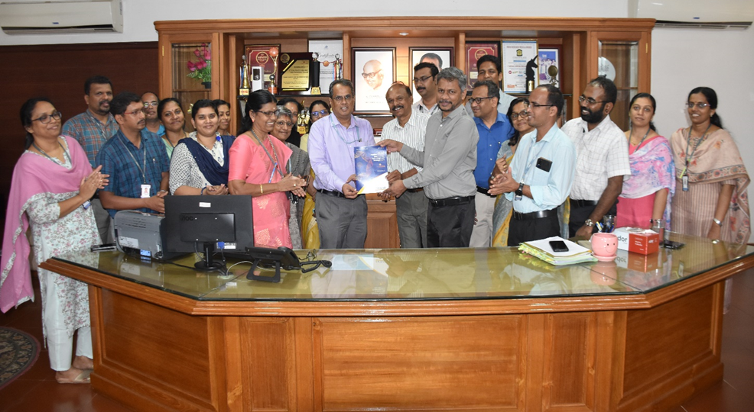
Chairman releasing Vol 1. Issue 2 (2023)

2. Webinar on Research Publication: The Research & Development (R&D) cell at FISAT has organized a webinar on “Research Publication and Journal Indexing” on 28th September 2023. Resource person: Dr. Elammaran Jayamani, Associate Professor, Swinburne University of Technology Sarawak Campus (SUTS). Around 30 faculty members and research scholars from various departments attended the webinar.

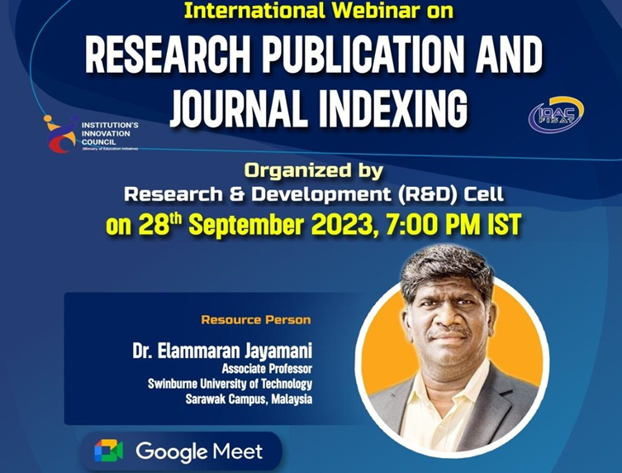

3. Amrit Kaal Vimarsh: Viksit Bharat@2047: The Research & Development (R&D) cell at FISAT has organized an invited talk titled “Role of Academia in Defense R&D eco system” on 23rd February 2024. Resource person: Dr. Ajith Kumar K, Director, Naval Physical & Oceanographic Laboratory (NPOL), DRDO. Around 240 Students and faculty members from various departments attended the session.
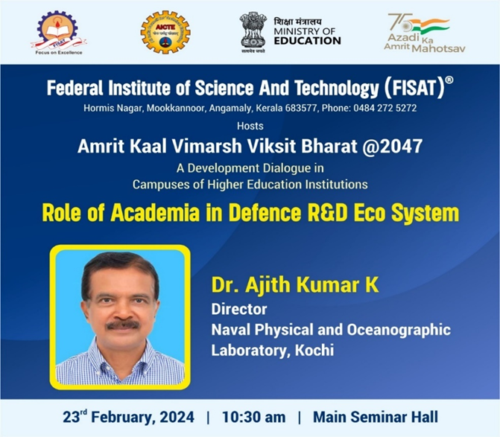

4. Invited Talk titled Essence of Research in Academe: The Research & Development (R&D) cell at FISAT has organized an invited talk titled “Essence of Research in Academe” on 14th March 2024.
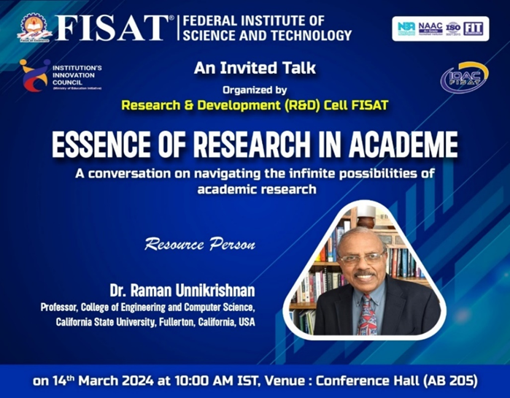
Resource person: Dr. Raman Unnikrishnan, Professor, College of Engineering and Computer Science, California State University, Fullerton, California, USA. Around 50 faculty members and research scholars from various departments attended the session.
5.A technical session on Research Methodology was organized on 24-01-2025. The resource person was Dr. R Sridharan, Professor, NIT Calicut. Around 50 faculty members and research scholars from various departments attended the session.

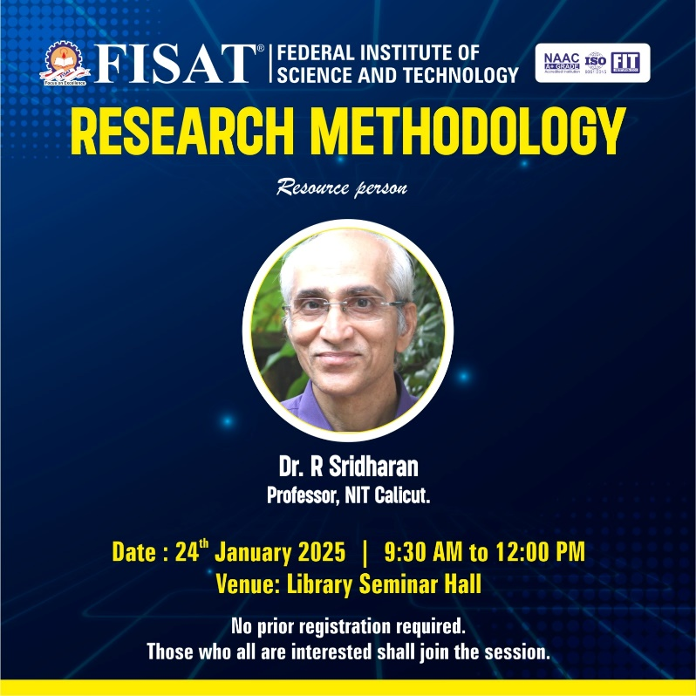

4. Project competitions and exhibitions

a) Women Hackathon 3.0: FISAT Technology Business Incubator (TBI) and Research & Development (R&D) cell, in collaboration with the Ministry of Micro, Small & Medium Enterprises (MSME) Gov. of India, organized the Women Hackathon 3.0 in August 2023. This event provided a platform for women-led teams to showcase their innovative ideas and an opportunity for incubation with funding. Six teams participated in the event and 4 ideas were shortlisted and recommended to MSME for funding.

b) Rural Innovators Meet (RIM) organized by KSCSTE: Rural Innovators Meet (RIM) is a programme for encouraging and promoting the unorganized rural and grass root innovators engaged in the development of rural technologies.

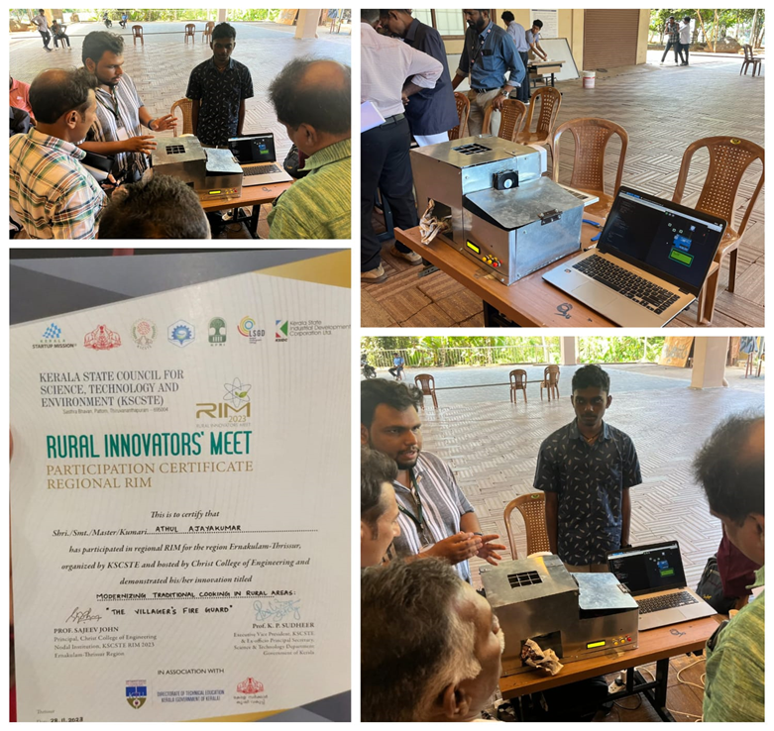

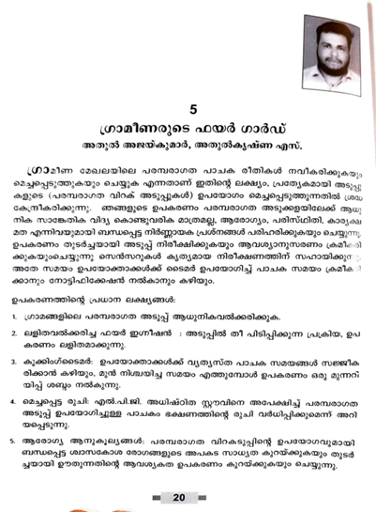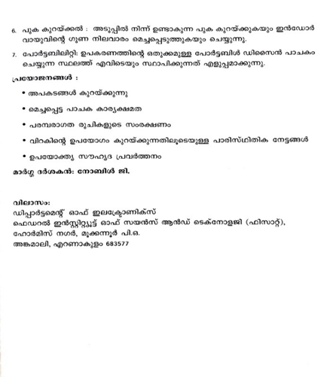

c) VSSC World Space Week 2023: Vikram Sarabhai Space Centre (VSSC), Liquid Propulsion Systems Centre (LPSC), ISRO Inertial Systems Unit (IISU) & Indian Institute of Space Science & Technology (IIST) under Indian Space Research Organization (ISRO) conducted a one-day workshop on 5th October 2023 in Trivandrum with the theme "Space and Entrepreneurship". The workshop offered an opportunity for our students to pitch their ideas in space sector.

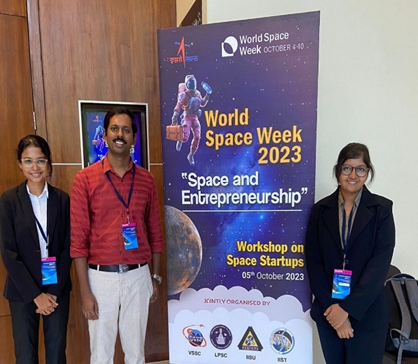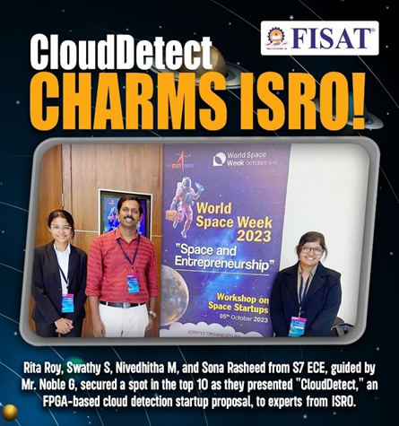
d) 7 women faculty & IEDC staff in charge attended the “Women in STEM are vital to Future Development" programme from FISAT organized by Kerala Startup Mission in collaboration with the British High Commission in India, Chevening alumni, and the University of Oxford.
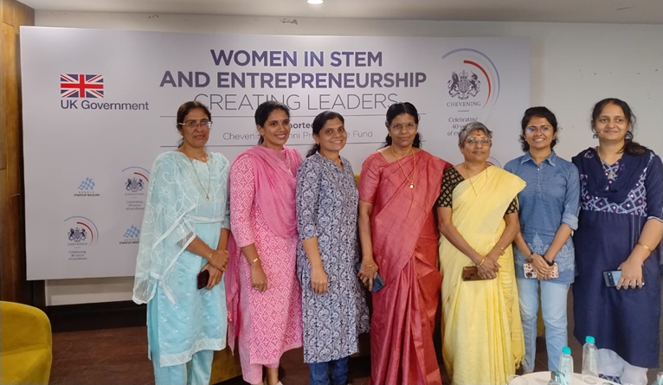

e) KETCON 2024 - APJ AKTU TECHFEST
3 student teams from FISAT have participated and won accolades at the TECHFEST organized by APJ Abdul Kalam Technological University, Thiruvananthapuram and hosted at Ahalia School of Engineering and Technology, Palakkad.
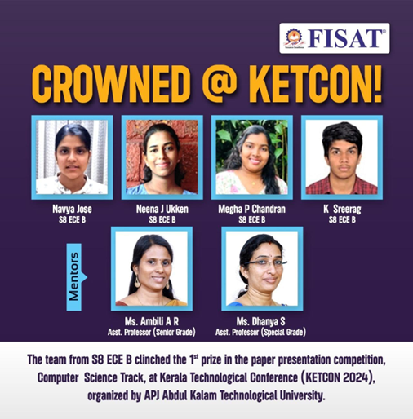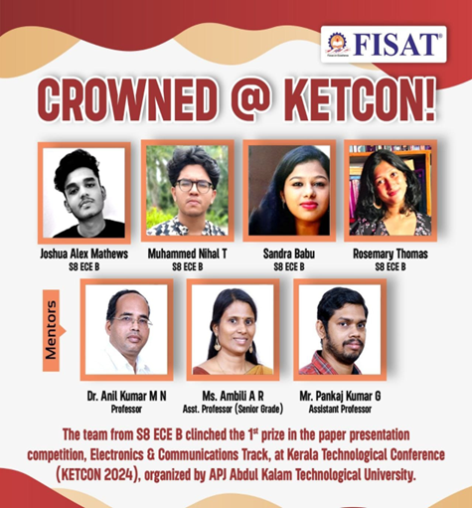
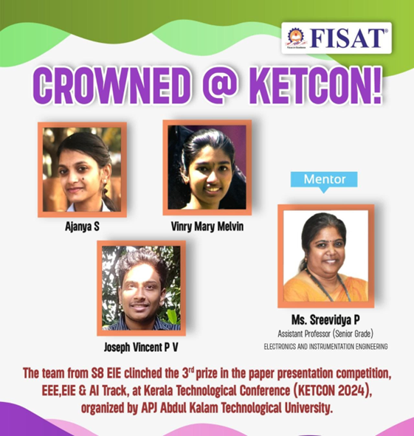
f) AICTE Millets Recipe Unleashing Talent (AMRUT)
AMRUT is a Millet recipe preparation competition for students, serving faculties and supporting staff from approved institutions to and come out with innovative yet traditional recipes. Two teams from FISAT submitted the application for AICTE Millets Recipe Unleashing Talent (AMRUT).
g) AICTE VAANI (Vibrant Advocacy for advancement and Nurturing of Indian Languages)
Two faculty attended the webinar on the launch of VAANI scheme. It was decided to apply for the VAANI scheme and we received a funding assistance offer for 2 lakh rupees to organise the seminar.
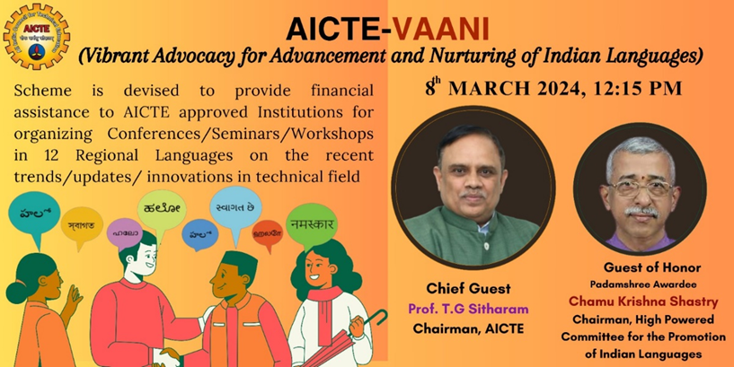

IPR Cell - Intellectual Property of FISAT
The Intellectual Property Rights (IPR) Cell at FISAT is set up under the R&D Cell with an aim to foster and endorse original ideas, designs or creations by inculcating innovation and creativity among the faculty and students of the institution. FISAT has instituted a variety of schemes and policies designed to bolster and facilitate the filing and publication of patent-worthy concepts.
The IPR Cell at FISAT organises regular awareness programmes and events to familiarise the concept of intellectual property and the need for protecting it through patents and copyrights. IPR Cell extends comprehensive assistance to faculty members and students in the process of patent application/filing and publishing of patentable ideas and also continuously monitors the process until the patent gets granted. Financial support is also allocated exclusively to published patents/intellectual property, under the stipulation that the Federal Institute of Science and Technology (FISAT) is a co-applicant in the application.
Activities of IPR Cell
- IPR awareness programme: Understanding Intellectual Property Rights (IPR): An Asset to Engineers
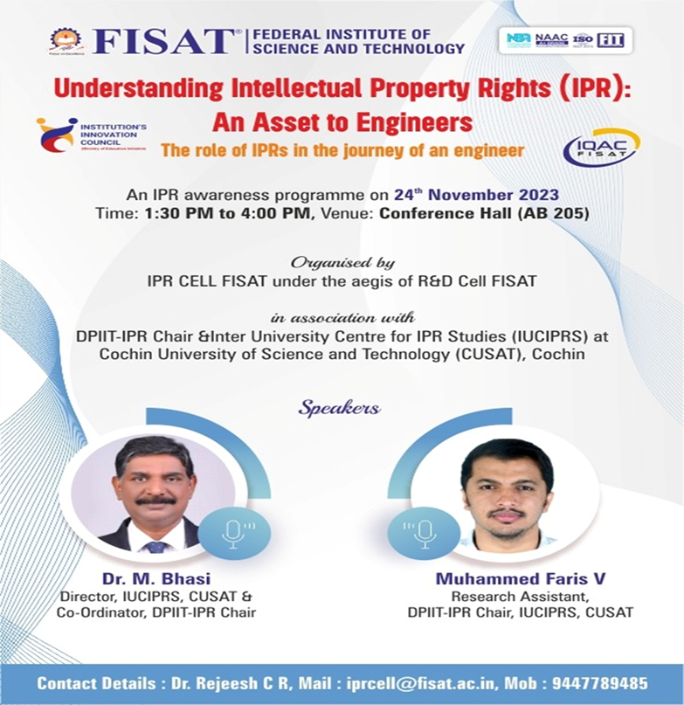
An IPR awareness programme titled “Understanding Intellectual Property Rights (IPR): An Asset to Engineers” was organised by the IPR CELL at FISAT in association with DPIIT-IPR Chair & Inter University Centre for IPR Studies (IUCIPRS) at Cochin University of Science and Technology (CUSAT), Cochin.
The programme was conducted on 24th Nov 2023 from 1:30 PM to 4:00 PM at Conference Hall (AB 205) of FISAT. The target audience included the students and staff of FISAT. A total of 62 participants attended the sessions. The sessions emphasized on the role of IPRs in the journey of an engineering graduate.
Resource Persons
Dr. M. Bhasi
Director, IUCIPRS, CUSAT &
Co-Ordinator, DPIIT-IPR Chair
Mr. Muhammed Faris V
Research Assistant
DPIIT-IPR Chair, IUCIPRS, CUSAT

2. Workshop on IPR studies: IPR Cell FISAT organized a One-day workshop on “Patents and Copyright Filing Procedures in India” on 18th August 2023. Resource person: Prof. J E Moshe Dayan (Coordinator, PSNA IPR Cell, PSNA CET, Dindigul). He has extensive knowledge and experience in the field of Intellectual Property Rights. 32 faculty members from various departments attended the workshop.
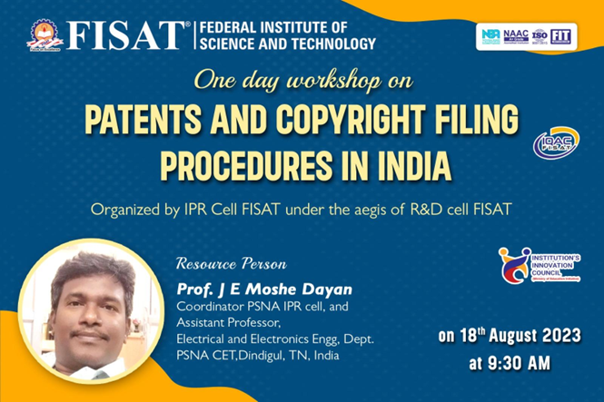
Research Grants

Academic Year 2023-2024
Grants offered from Government and Non-Government agencies for research projects, sponsored events during Academic Year 2023-24.
A total of Rs 35,47,898/- has been received/sanctioned for the Academic Year 2023-2024.
Item | Amount
Grants for startups | 5,00,000/-
University Research Grants | 22,17,238/-
KTU Student Project | 93,260/-
Seed Money for Research | 6,00,000/-
Grants for Organizing Conference | 1,10,000/-
Grants for Organizing Workshops/FDP/Seminar | 25,000/-
Grants for IPR Awareness and patent filing | 2,400/-
Total | 35,47,898/-

Grant for Startups:
A startup (Rastelx Technologies Private Ltd) incubated at federal labz FISAT has received a grant of Rs 5,00,000/- from the Ministry of Agriculture and farmers welfare through the Kerala Agriculture University to develop SEVAFARM-a web portal for farmers to get a fair price. Ms. Raji P and Ms. Honey Devassy are the founders of the startup and are Assistant professors in the EIE department.

CERD Research Grants
Sl.  No. | Name of the  Investigator | Project No. | Funding Agency | Title of the project and duration | Amount sanctioned
1 | Lakshmi Raj/  Dr. ArunKumar M N | U.O.No.617/2023/KTU  U.O.No.3177/2023/KTU | CERD, KTU | Development of novel techniques for automated detection of cervical cancer (3 years) | 5,70,702/-
2 | Jyotsna E/  Dr. Paul P Mathai | U.O.No.804/2023/KTU | CERD, KTU | Human action recognition using machine learning  (3 years) | 1,16,667/-
3 | Ms. Shanooja M A/  Dr. Anil kumar M N | U.O. No. 617/2023/KTU  U.O.No.3177/2023/KTU | CERD, KTU | Development of a novel symmetric algorithm specific to selected prime fields (3 years) | 9,60,000/-
4 | Mr. Ajith S Panackal/ Dr. Anil kumar M N | U.O.No.617/2023/KTU  U.O.No.3177/2023/KTU | CERD, KTU | Analysis of Cryptographic Algorithms (3 years) | 5,69,869/-
Total |  |  |  |  | 22,17,238/-

KTU Student Project
A total of Rs 93,260/- has been sanctioned.
Sl.  No | Name of PI | Title of Project | Department | Amount Sanctioned
1 | Dr. Harish T M, Assistant Professor | Methodological analysis into the mechanical and microstructural attributes of functionally graded Inconel 825-SS 304 L manufactured using wire arc additive manufacturing | Mechanical Engineering | 35,000/-
2 | Mr. Pankaj Kumar G, Assistant Professor | Efficient Image-to-Text Conversion for Railway and Disaster Management using LoRaWAN and Asus Prime X570 | Computer Science and Engineering | 31,000/-
3 | Ms. Dhanya S, Assistant Professor | Autonomous Search and Rescue Rover | Electronics and Communication Engineering | 27,260/-
Total |  |  |  | 93,260/-

Seed Money for Research- Supported by FISAT
A total of 6 lakh rupees were granted to 12 principal investigators across 6 departments of FISAT. A list of Selected Projects in 2023-24 is given below.
Sl.  No | Name of Applicant | Title of Project | Sanctioned amount
1 | Ms. Panjami K  Asst. Professor,  Civil Engineering Dept. | Study of Seismic Wave Propagation on underground cavities through Model Studies – A Step towards developing Low-cost Detection Tool | Rs. 70,000/-
2 | Dr. Harish T M  Asst. Professor (Spl. Grade),  Mechanical Engineering Dept. | Advanced Superalloy based Functionally Graded Materials development for critical applications through Metal Additive Manufacturing: Fabrication and Analysis | Rs. 70,000/-
3 | Dr. Sona Narayanan  Asst. Professor (Spl. Grade),  Science and Humanities Dept. | Development of cellulose nanocomposites for bone tissue engineering | Rs. 65,000/-
4 | Ms. Ambili A R  Asst. Professor (Sr. Grade),  Electronics and Communication Engineering Dept. | SIGN-LIPDETECTRON | Rs. 60,000/-
5 | Dr. Keerthi G. Nair  Asst. Professor,  Science and Humanities Dept. | Bimetallic nanoparticles embedded Carbon nanostructures-based room temperature Hydrogen gas sensors | Rs. 60,000/-
6 | Mr. Noble G  Asst. Professor (Spl. Grade),  Electronics and Communication Engineering Dept. | Development of hardware architectures for Artificial Intelligence (AI) | Rs. 60,000/-
7 | Ms. Anisha Joseph  Asst. Professor (Spl. Grade),  Science and Humanities Dept. | A Study on SnO₂, PANI/ SnO₂ Nanocomposites and Thin Films on Acetone and LPG Sensing | Rs. 50,000/-
8 | Ms. Vidya T P  Asst. Professor (Spl. Grade),  Science and Humanities Dept. | Green synthesis of metal nanoparticles and their characterization | Rs. 50,000/-
9 | Ms. Raji P  Asst. Professor (Spl. Grade),  Electronics and Instrumentation Engineering Dept. | Wearable tracking device for kids | Rs. 50,000/-
10 | Dr. Abi P Mathew  Professor, Electronics and Instrumentation Engineering Dept. | Less Water Urinal | Rs. 25,000/-
11 | Lt. Dr. Prasad J C  Professor, Computer Science and Engineering Dept. | A Decentralized Approach to Certificate Management: Leveraging Blockchain Technology to Enhance Security and Transparency | Rs. 25,000/-
12 | Dr. Anish Mathew K  Asst. Professor (Sr. Grade),  Electronics and Instrumentation Engineering Dept. | Generation of electricity from solid waste material | Rs. 15,000/-
 |  | Total | Rs. 6,00,000/-
 |  | Six lakh Rupees only

Grants Received to organise Events
A total of Rs 1,37,400/- has been sanctioned for the Academic year 2023-2024.
Item | Department | Agency | Amount
SPECon-2024: Second International Conference on Smart Technologies for Power and Renewable Energy on April 2 - 4, 2024 | EEE | KSCSTE | 50,000/-
 |  | KTU | 60,000/-
3-day National Seminar | CE | KSCSTE | 25,000/-
KAPILA: Kalam Program for IP Literacy and Awareness | IPR Cell | MoE’s Innovation Cell (MIC) | 2,400/-
 |  | Total | 1,37,400/-

Academic Year 2024-2025
Grants offered from Government and Non-Government agencies for research projects, and sponsored events during Academic Year 2024-25.
A total of Rs 15,01,000/- has been received/sanctioned for the Academic Year 2024-2025.

Item | Amount
Grants for startups | 6,00,000/-
Research Seed Money | 1,71,000/-
KTU Student Project | -
Other Student Projects | -
Grants for Organizing Workshops/FDP/Seminar | 5,50,000/-
Grant for Organizing Conference | 1,60,000/-
Grants for IPR Awareness and patent filing | 20,000/-
Total | 15,01,000/-

Woman Productization Grant:
A startup (Rastelx Technologies Private Ltd) incubated at federal labz FISAT has received a productization grant of Rs 6,00,000/- from Kerala Startup mission to develop COMPANION- a mobile app for kids and elderly people. Ms. Raji P and Ms. Honey Devassy are the founders of the startup and are Assistant professors in the EIE department.

RSM Research Seed Money 2024
A total of Rs 1,71,000/- has been sanctioned.
Sl.  No | Name of PI | Title of Project | Department | Amount Sanctioned
1 | Dr. Keerthi G. Nair, Assistant Professor | Carbon nanofibers-based Room temperature Hydrogen gas sensors | Science and Humanities | 88,500
2 | Mr. Noble G, Assistant Professor | Configurable RISC-V based Neural Network Accelerator Design for High-Performance AI applications. | Electronics and Communication Engineering | 82,500
Total |  |  |  | 1,71,000/-

Grants Received to organise Events
Item | Department | Agency | Amount
3 Day Seminar on Green Energy and Sustainability: Combating Global Warming from 20/11/2024 to 22/11/2024 | R&D Cell | AICTE-VAANI  (Vibrant Advocacy for Advancement and Nurturing of Indian Languages) scheme | 2,00,000/-
Emerging Trends and Innovations in Additive Manufacturing from 20/01/2025 to 25/01/2025 | ME | AICTE Funded ATAL FDP | 3,50,000/-
SECON 24 | CE | KTU-CERD Grant for Organizing Conference | 60,000/-
ICAEMS 2024 | Science and Humanities | ANRF (DST- SERB) Grant for Organizing Conference | 1,00,000/-
Innovate and Insulate: Workshop on IPR | IPR Cell | KSCSTE-IPRICK Kerala | 20,000/-
KAPILA: Kalam Program for IP Literacy and Awareness | IPR Cell | MoE’s Innovation Cell (MIC)
 |  | Total | 7,30,000/-

